Static website hosting using aws
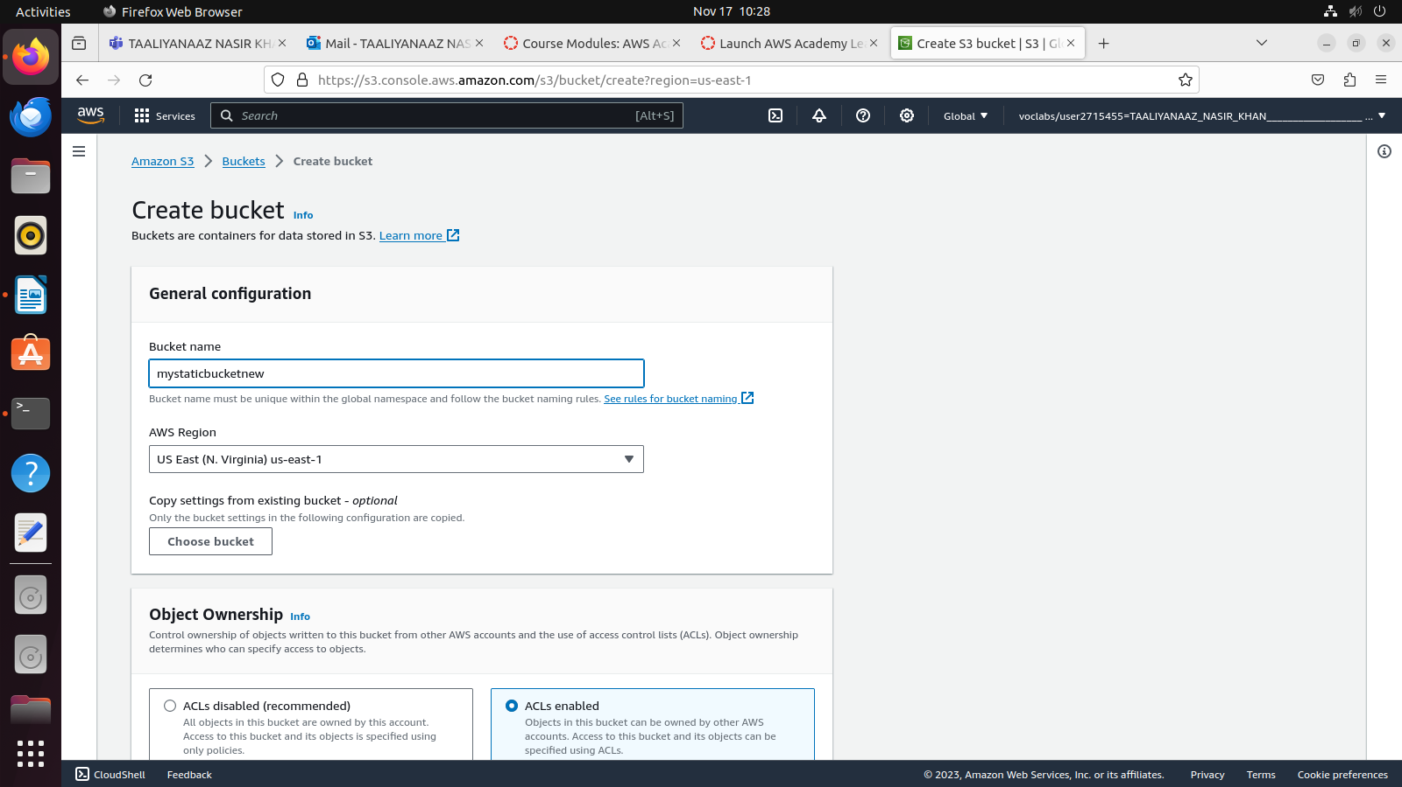
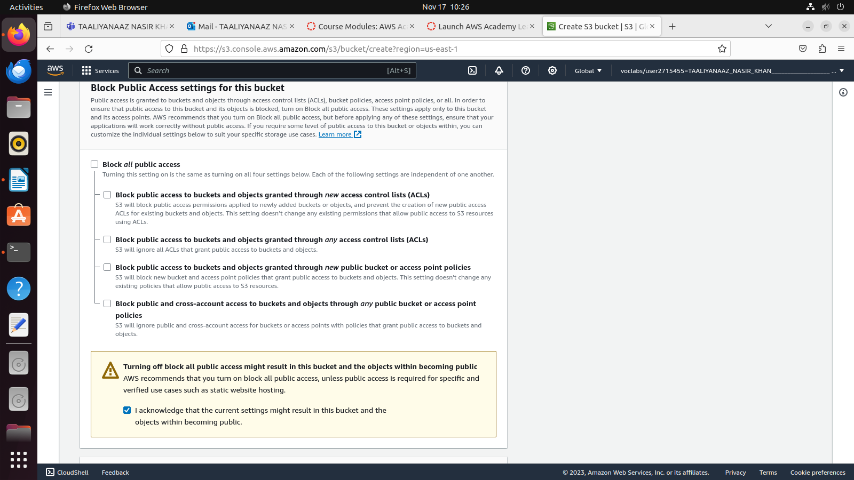

Leave everything as it is and click on create bucket

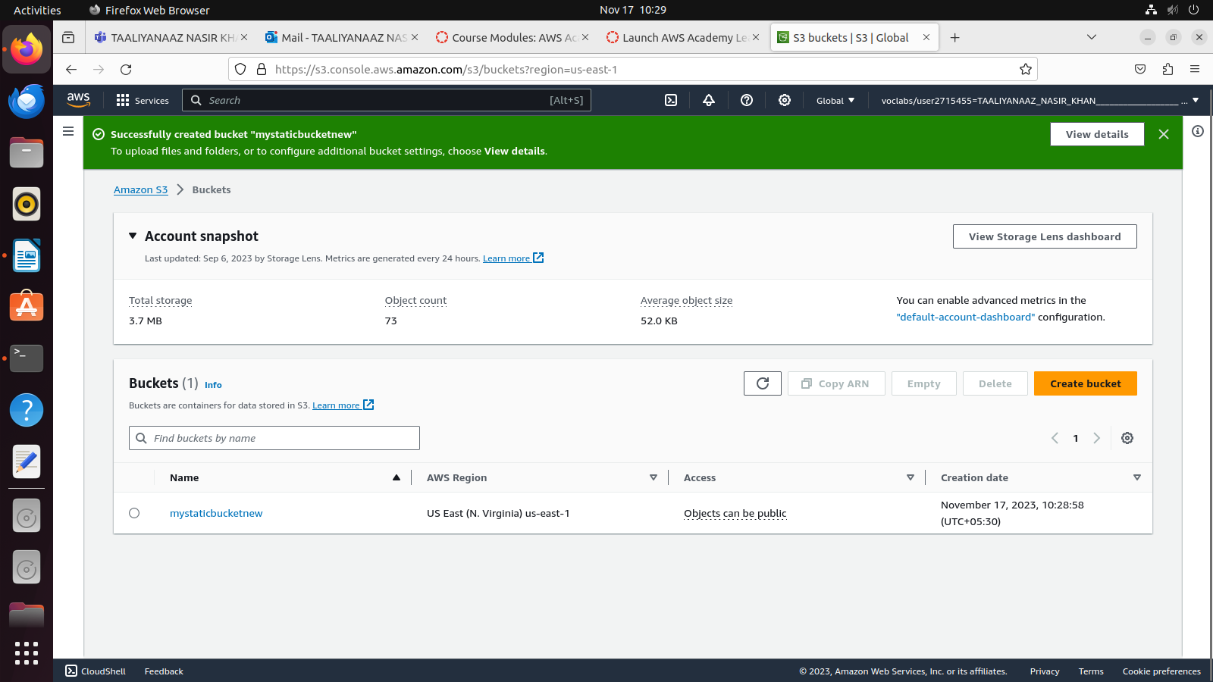
Upload the source code by clicking on the bucket name
First do add files and upload index.html
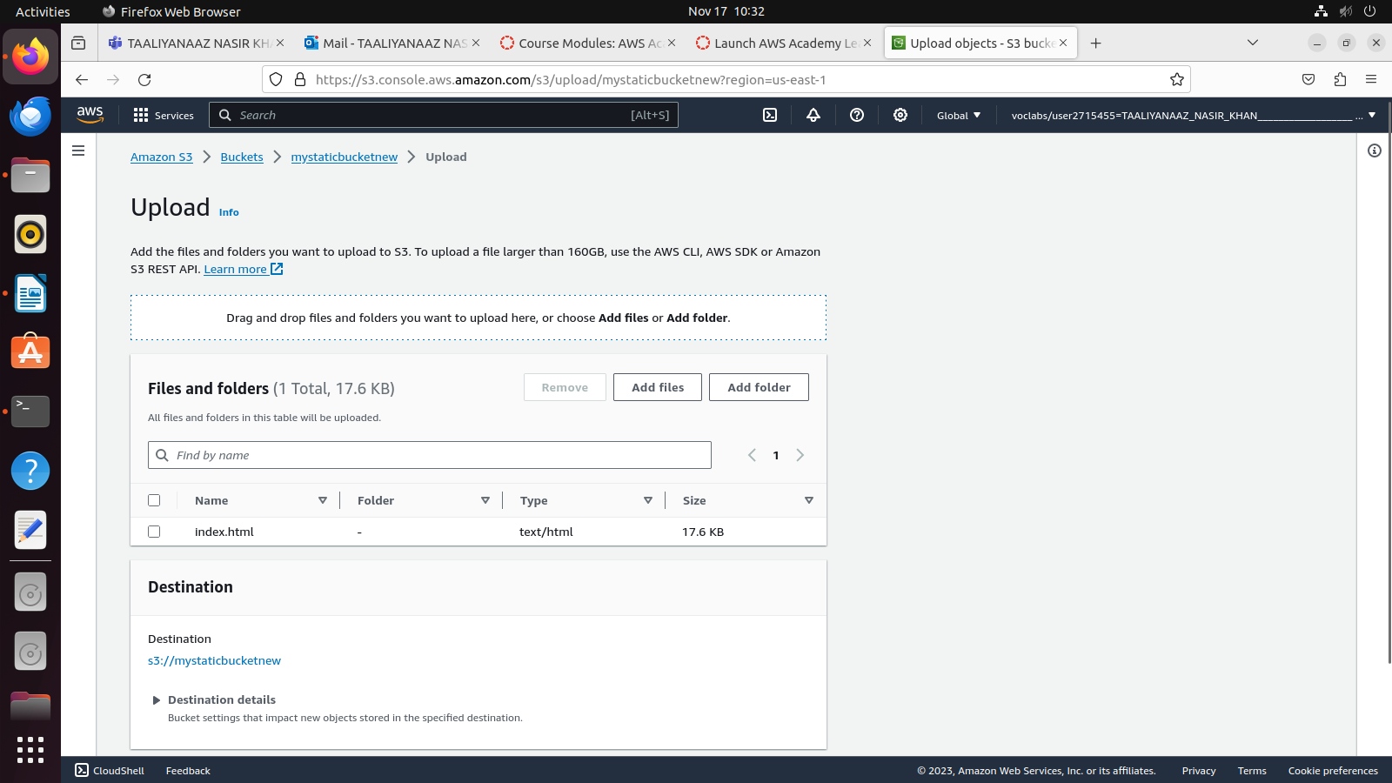
Then do add folder and upload asset and image files
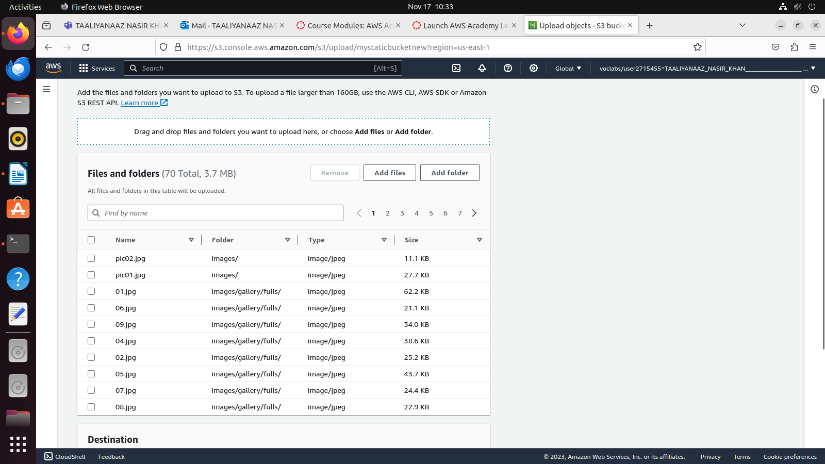
click on upload
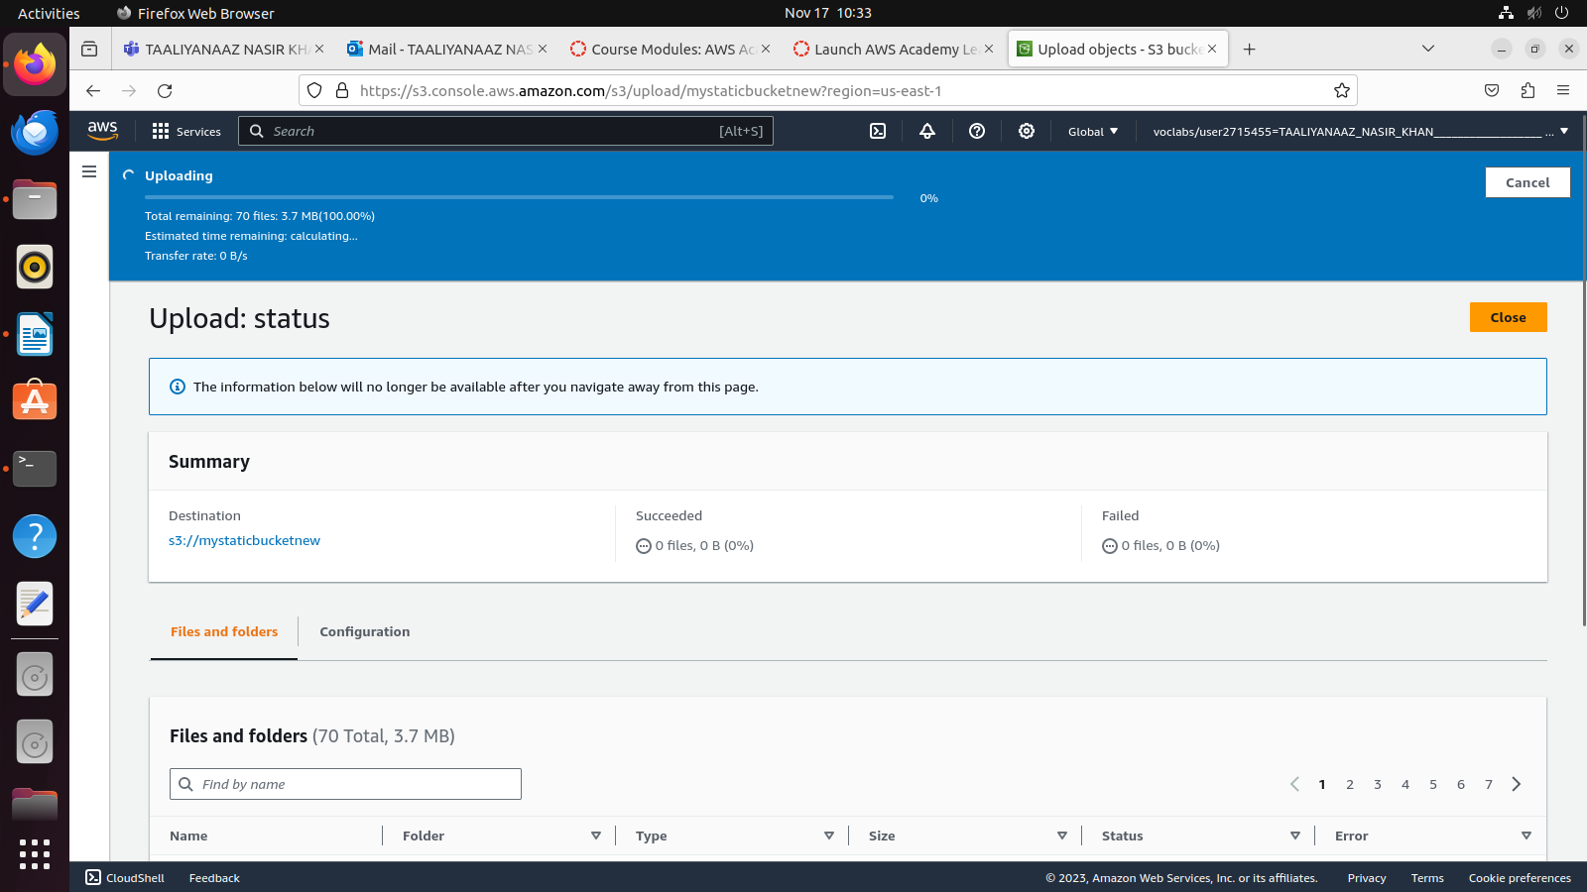

once upload is succeeded, go to properties
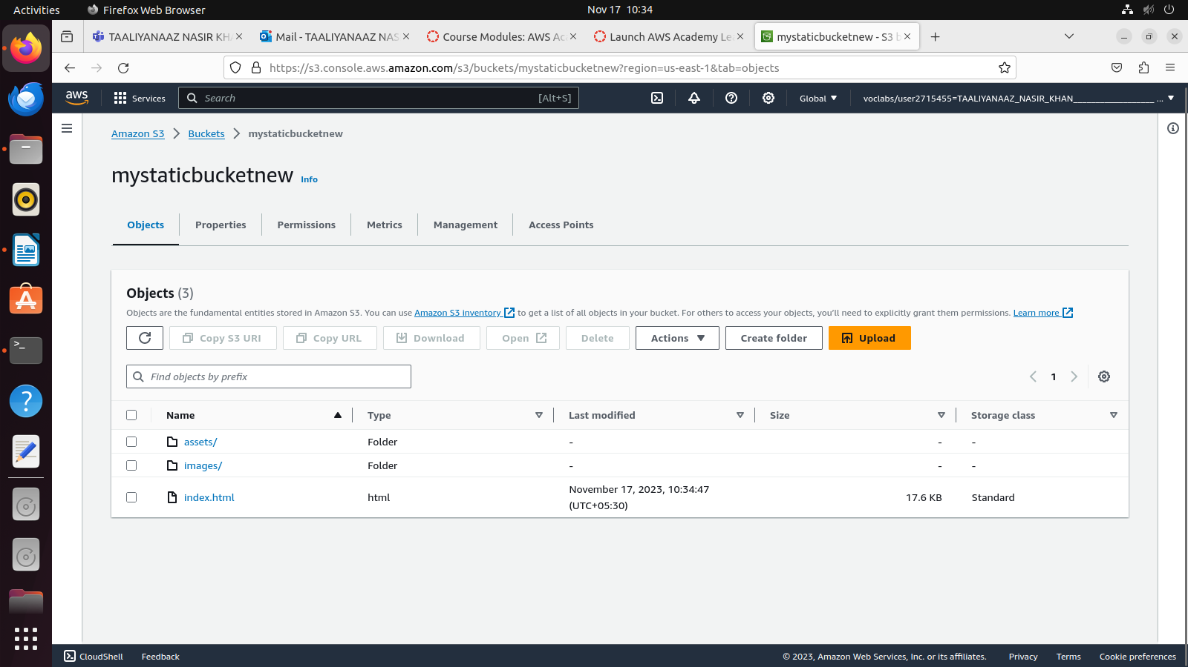
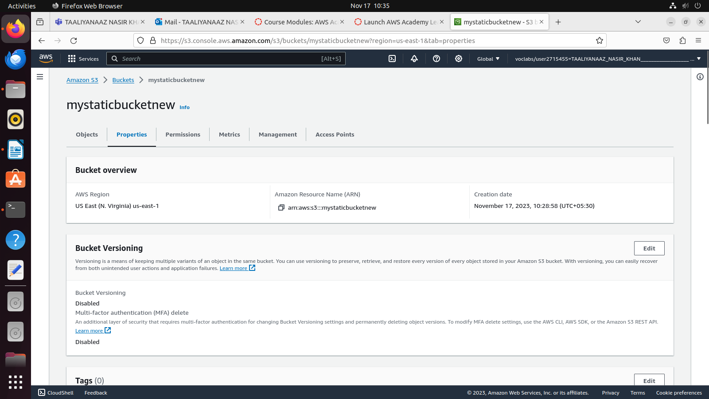
Scroll down and edit static website
Enable the Host static website part
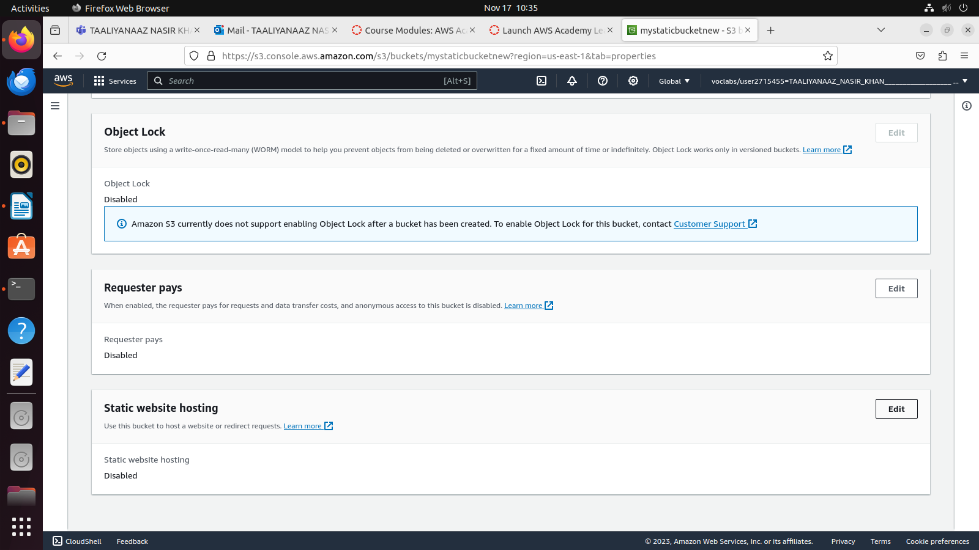
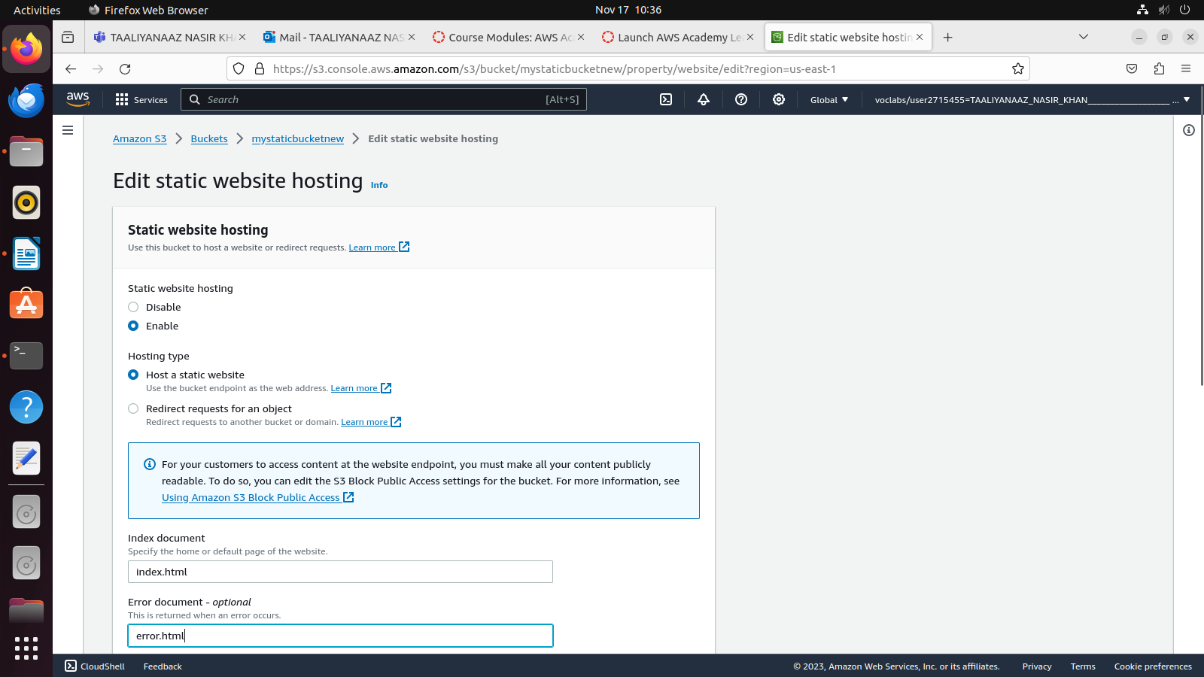
error.html is optional and save changes

A link would have been generated at the static website hosting part
Observe the ss

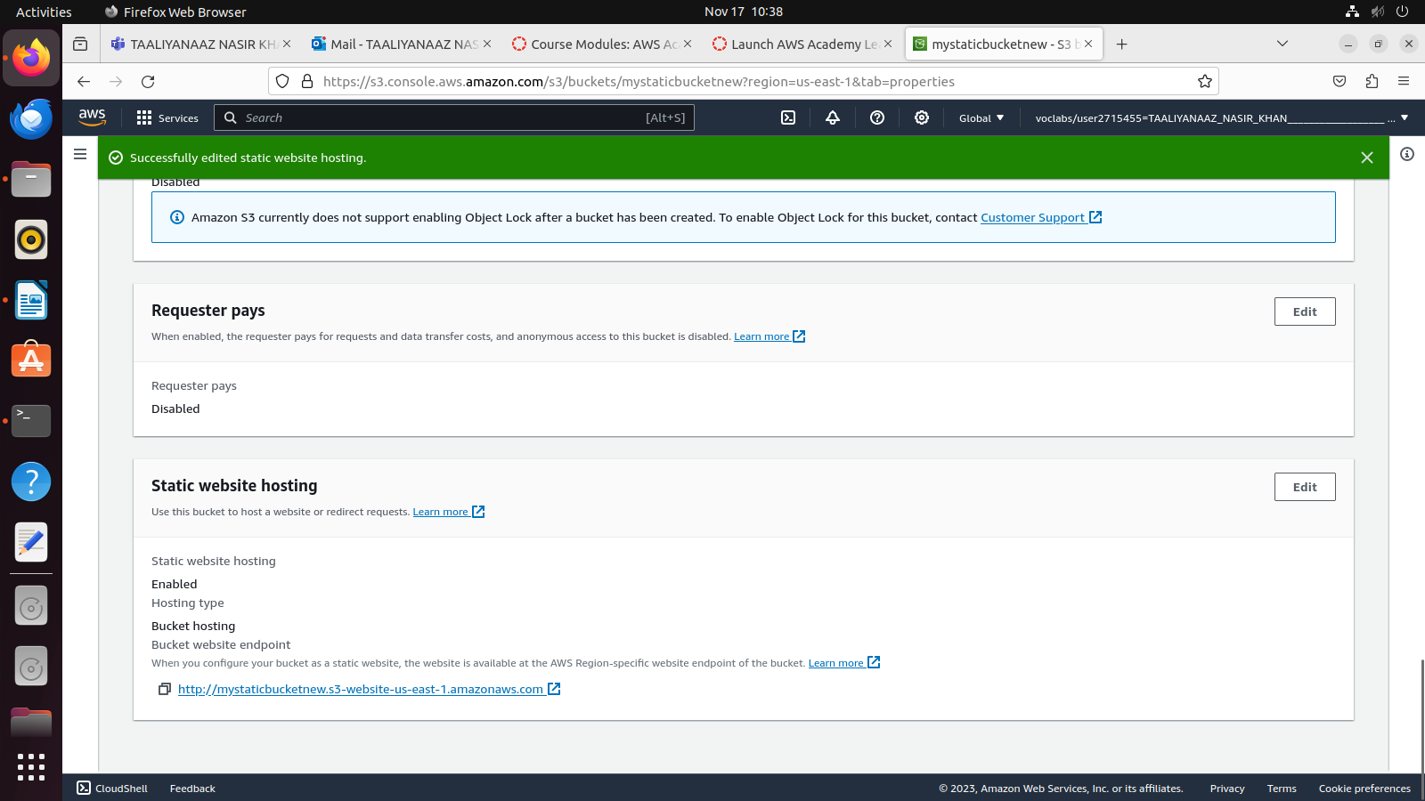
Click on all three and go to action dropdown and choose make public

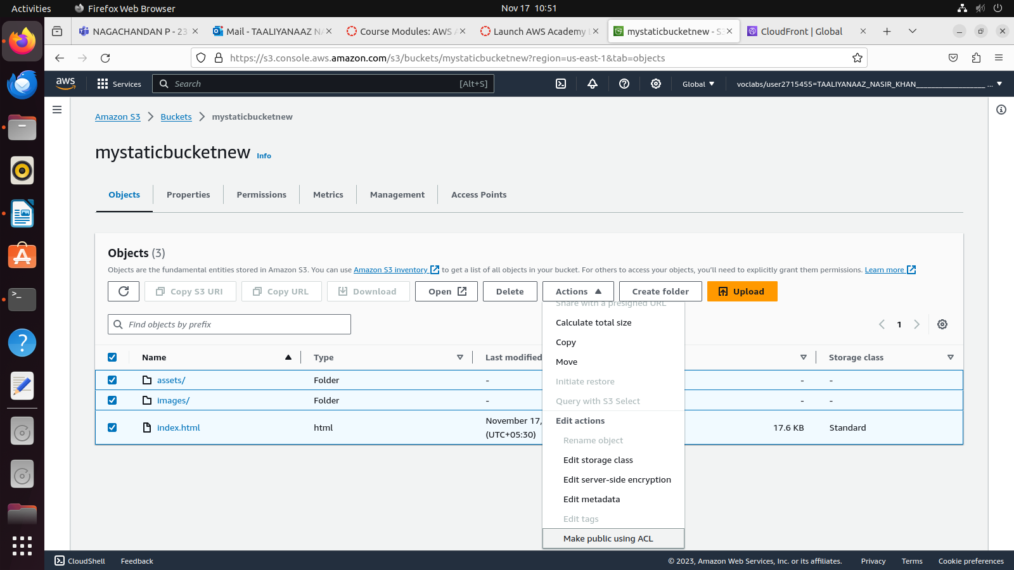

Now to go properties and click on the link, if itn talkes time to load just put http://<link>

Search for cloudfront
and Create a cloudFront distribution
Click on the origin domain and you will be able to choose the cfreated s3 bucket
you can skip original path

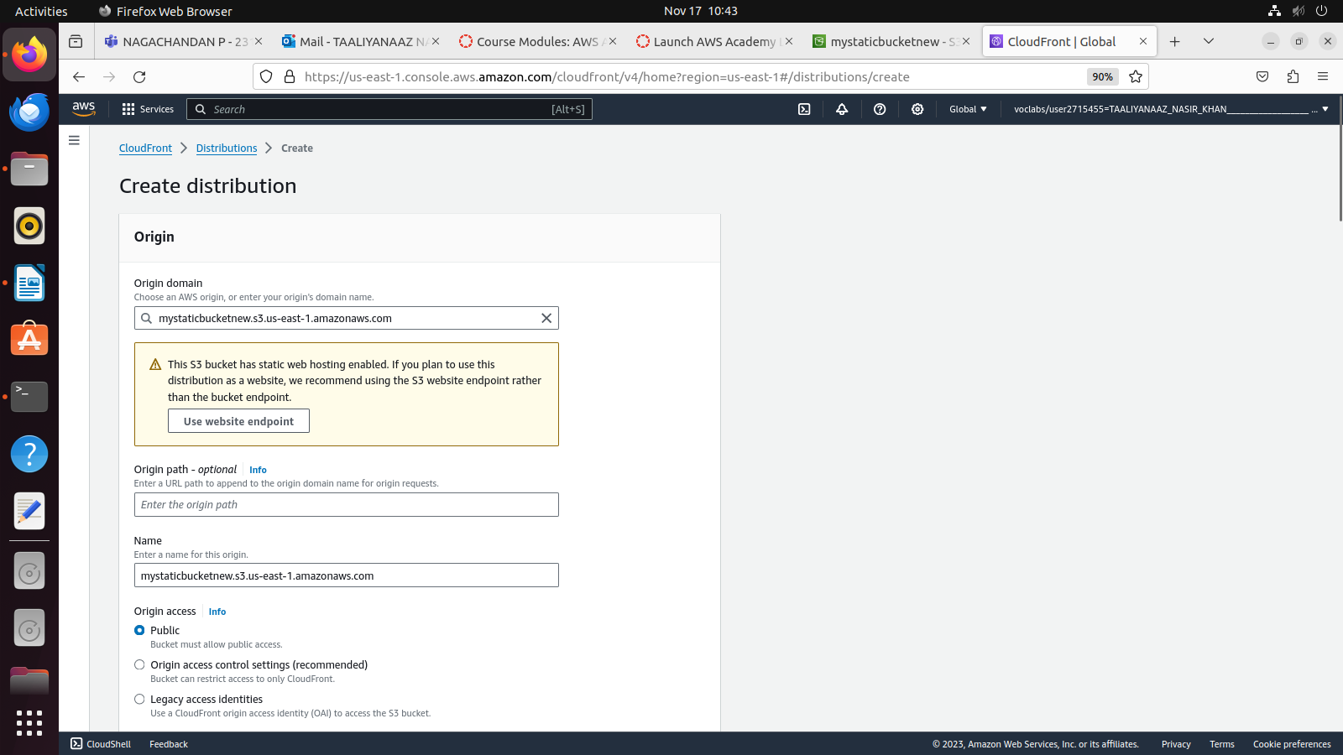

Rest of the fields , leave it as it is
Disable WAF

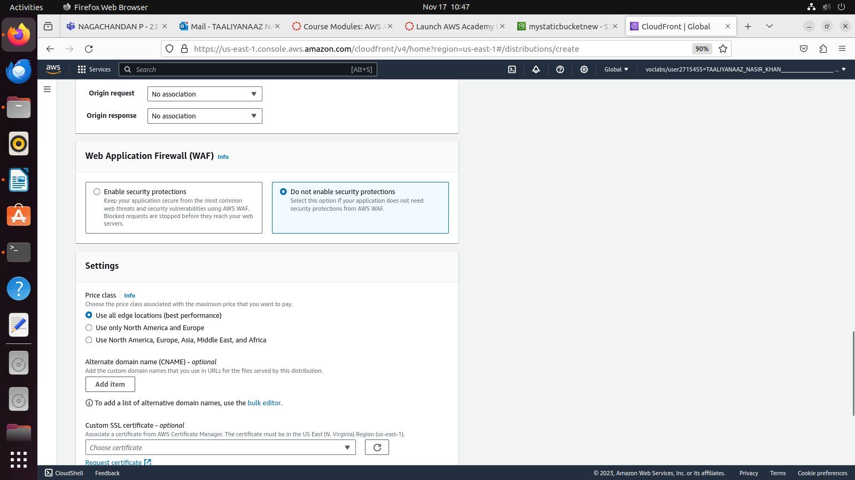

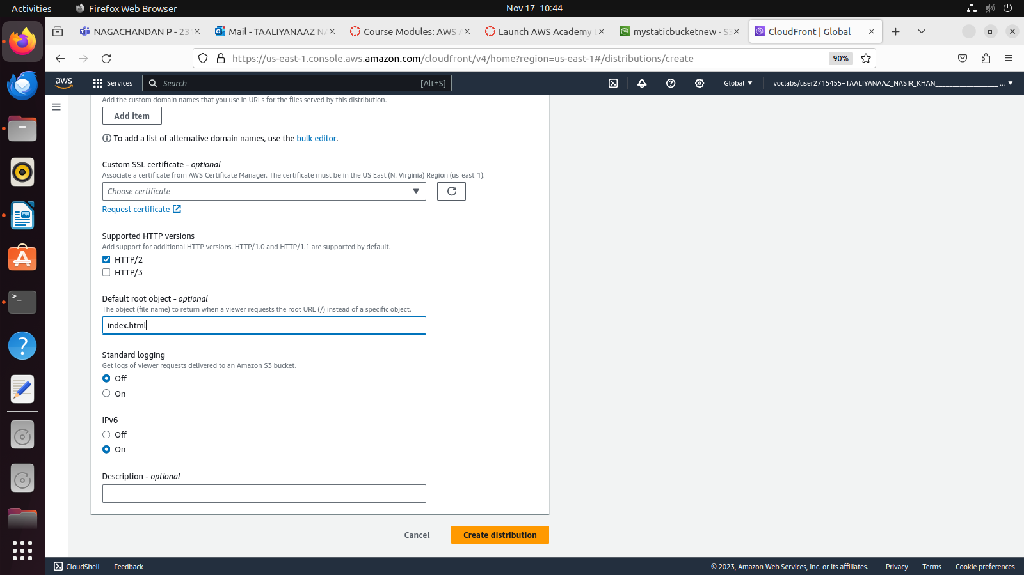

Click on create distribution

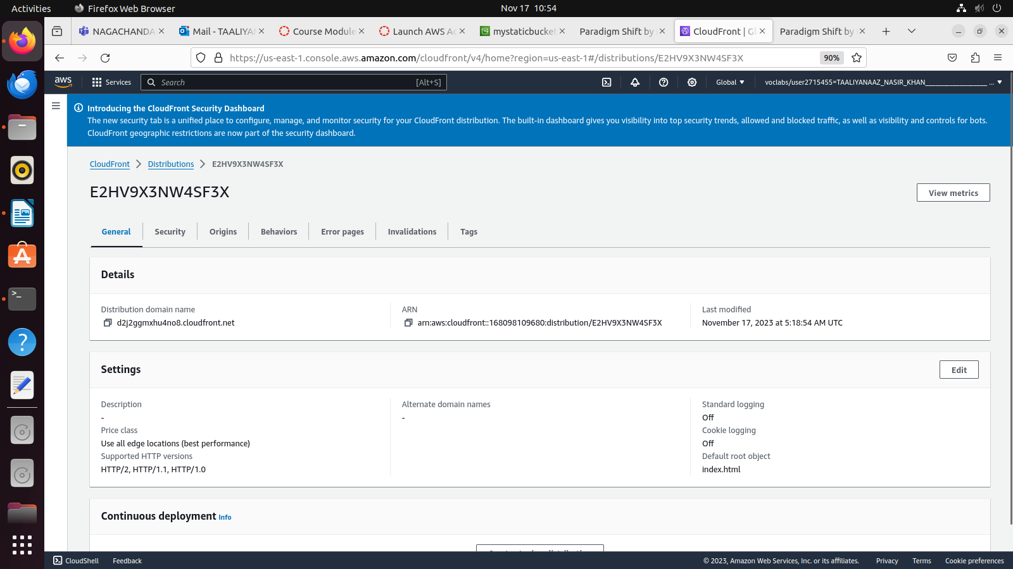

Copy the Distributoion domain name and put that in browser

